

**Capstone Project Final Report**

**Online Real Estate Auction**

|  |  |
| --- | --- |
|  | **Online Real Estate Auction** |
| **Group Members** | Lương Văn Hải – HE141667  Nguyễn Quốc Việt – HE140773  Lê Tuấn Hưng – HE140871 |
| **Supervisor** | Lecturer: Phạm Ngọc Hà |
| **Capstone Project code** | Online Real Estate Auction |

**– HaNoi, Jun, 2021 – 2021**

# Acknowledgement

Foremost, we would like to express our sincere gratitude to our supervisor: Mr. Pham Ngoc Ha for the continuous support of our project development, for his patience, motivation, enthusiasm and immense knowledge. His guidance helped us in all the time of this project. We could not have imagined having a better advisor and mentor for our project. Besides our supervisor, we would like to thank all of our friends who listen to projects and give more suggestions for us, our teammates who have done their best to make to complete the website Online Real Estate Auction.

In addition, we would also like to thanks the instructors at FPT University for all the classes. The instructors have used the experiences and enthusiasm to give us during this period of four years to get here today.

Last but not least, we would like to thank FPT University for giving us this precious opportunity to constantly study and improve ourselves. What we learned through this project will be the basis for us to work well after graduation...

# CONTENT

**CHAPTER 1 ......................................................................................................... 9**

**INTRODUCTION -** 紹介 **...................................................................................... 9**

1. **Purpose** （目的） **...................................................................................................... 9**
2. **Project Information** （プロジェクトの情報） **............................................................ 9**
3. **Project Team** （プロジェクトチーム） **................................................................... 9**
   1. Supervisor (監督者) ............................................................................................. 9
   2. Team Members (チームの構成員) ....................................................................... 9
4. **Background** **(**バックグラウンド**) ............................................................................ 10**
5. **The current system**（存在しているシステム） **........................................................ 10**
   1. Trippy ................................................................................................................... 10
   2. KLOOK .................................................................................................................. 13
6. **Proposed Solution** （提案されているソリューション） **...................................... 14**
   1. Solution Description （ソリューション説明） ............................................... 14
   2. System Actors （システムアクター） ............................................................. 15
      1. Web/Front-End （ウェブ／フロントエンド） ......................................... 15
      2. Admin Board （管理者） ............................................................................ 15
   3. System Features （システム特徴） ................................................................. 15
   4. Intended Screen Flow （意図されている画面フロー） ................................. 16
      1. GoBoKi screen flow （GoBoKi 画面フロー）............................................ 16
      2. CMS screen flow （CMS 画面フロー） ..................................................... 17
   5. Technologies （技術） ..................................................................................... 19
7. **Constraints & Assumptions** （制約＆仮定） **.......................................................... 19**
   1. Project Constraints （プロジェクト制約） ..................................................... 19
   2. Project Assumptions （プロジェクトの仮定） ............................................... 19
8. **Out of scope functions** (範囲外) **............................................................................. 19**

**CHAPTER 2 ....................................................................................................... 21**

**PROJECT PLAN -** プロジェクト計画**................................................................ 21**

1. **Overview** （概要） **.................................................................................................. 21**
   1. Scope （範囲） ................................................................................................ 21
   2. Objectives （目的） ......................................................................................... 21
   3. Project Risks （プロジェクトリスク） ........................................................... 21
2. **Management Approach** （プロジェクト管理アプローチ） **.................................. 22**
   1. Project Process （プロジェクトプロセス） ................................................... 22
   2. Change Management （変更管理） ................................................................. 22
   3. Quality Management （品質管理） ................................................................. 23
      1. Defect Prevention Strategy （欠陥防止戦略）........................................... 23
      2. Review Strategy （レビュー戦略）............................................................ 23
   4. Project Training Plan （プロジェクト研修計画） ........................................... 23
3. **Estimation & Master Schedule** （見積もりとマスタースケジュール） **................ 24**
   1. Project Size （プロジェクトサイズ） ............................................................ 24
      1. Web ................................................................................................................ 24
      2. CMS ................................................................................................................ 25
   2. Deliverables （成果物） ................................................................................... 25
   3. Detail Schedule （詳細なスケジュール） .......................................................... 26
   4. Project Organization （プロジェクト組織） ................................................... 26
      1. Team & Structures （チームと構造）........................................................ 26
      2. Roles & Responsibilities （役割と責任）.................................................... 26
   5. Communication （プロジェクトコミュニケーション） ............................... 27
      1. Communication Plan （コミュニケーションプラン） ............................. 27
      2. External Interface （外部インタフェース） ............................................. 27
   6. Configuration Management （構成管理） ....................................................... 28
      1. Tools & Infrastructures （道具とインフラ） ............................................. 28
      2. Document Management （資料管理） ...................................................... 28
      3. Source Code Management （ソースコード管理）.................................... 29

**CHAPTER 3 ....................................................................................................... 30**

**SOFTWARE REQUIREMENT SPECIFICATION -** システム要求仕様 **................... 30**

1. **Product Scope** （製品の範囲） **............................................................................... 30**
2. **Functional Requirements** （機能要求） **................................................................. 30**
   1. Use case diagram （ユースケース図） .............................................................. 30
   2. Business Rules （ビジネスルール） ................................................................ 32
   3. Use Cases （ユースケース） ........................................................................... 33
      1. Admin & Staff （管理者＆スタッフ） ....................................................... 35
      2. User （ユーザー） .................................................................................. 134
      3. Guest （ゲスト） ..................................................................................... 166
3. **Non-Functional Requirements** （非機能要件）**....................................................... 170**
   1. Security （セキュリティ） ............................................................................ 171
   2. Accuracy （正確さ） ...................................................................................... 171
   3. Usability （ユーザビリティ） ....................................................................... 171
   4. Performance （パフォーマンス） ................................................................... 171
   5. Availability （可用性） ................................................................................... 171
   6. Maintainability （メンテナンス性） ............................................................. 171
   7. Performance （パフォーマンス） ................................................................ 172
   8. Reliability （信頼性） ........................................................................................ 172
4. **Entity Relationship Diagram**  （テーブル **ER** 図） **............................................. 172**

**CHAPTER 4 ..................................................................................................... 173**

**SOFTWARE DESIGN -** システム設計の説明 **.................................................. 173**

1. **Purpose** （目的） **.................................................................................................. 173**
2. **Architecture Overview** (アーキテクチャの概要) **................................................. 173**
   1. System architecture (システムのアーキテクチャ) ...................................... 173
   2. System Architecture Explanation (システムのアーキテクチャの説明) .......... 173
      1. React............................................................................................................. 174
      2. Spring Boot ................................................................................................... 174
      3. Spring Data JPA ............................................................................................. 175 2.2.4. MySQL .......................................................................................................... 175

2.2.5. Amazon web services .................................................................................... 175

1. **System Design** (システムの設計) **......................................................................... 176**
   1. Database Design (データベース設計) ........................................................... 176
      1. Explanation of Database Decision （データベース決定の説明） ........... 176
      2. Database Diagram (データベース図)....................................................... 177
      3. Data Dictionary (データディクショナリ) ............................................... 177
2. **Detail Design** (詳細な設計) **................................................................................... 185**
   1. Detail Class Diagram (詳細クラス図) ............................................................. 186
      1. Authentication （認証） ........................................................................... 186
      2. Category （カテゴリー）......................................................................... 188
      3. City （市） ................................................................................................ 190
      4. Game （ゲーム） ..................................................................................... 192
      5. Order （注文） ......................................................................................... 195
      6. Place （場所） .......................................................................................... 198
      7. Ticket （チケット） ................................................................................. 201
      8. TicketType （チケットタイプ） .............................................................. 203
      9. User （ユーザー） ................................................................................... 205
      10. VisitorType （ビジタータイプ） ........................................................... 209
   2. Sequence Diagram (シーケンス図) ................................................................ 212
      1. Content Management System (コンテンツ管理システム) ..................... 212
      2. Guest （ゲスト） ..................................................................................... 240
      3. User （ユーザー） ................................................................................... 243

**CHAPTER 5 ..................................................................................................... 247**

**SOFTWARE TESTING -**ソフトウェアテスト **................................................. 247**

1. **Introduction** (紹介)**............................................................................................... 247**
   1. Purpose (目的) .............................................................................................. 247
   2. Scope of Testing (テスト範囲) ...................................................................... 247
      1. Testing phases （テスト段階） ................................................................ 247
      2. Testing types （テストの種類） .............................................................. 248
      3. Testing range （テストの範囲） .............................................................. 248
2. **Test Plan** (テスト計画) **................................................................................... 248**
   1. Testing Tools and Environment (テスティングツールと環境) ........................ 248
      1. Testing Tools (テスティングツール) ...................................................... 248
      2. Testing Environment (テスティングの環境) ........................................... 249
   2. Resources and Responsibilities (資源と責任) ................................................ 250
   3. Test Strategy (テスト戦略) .......................................................................... 250
      1. Test Model (テストのモデル) ................................................................. 250
      2. Test Process (テストプロセス) ............................................................... 251
      3. Test Types (テストの種類) ...................................................................... 251
      4. Test Stages (テスト段階) ......................................................................... 253
      5. Test Schedule (テスト スケジュール) ..................................................... 254
      6. Test Deliverables(テスト成果物) ................................................................ 254
      7. Resource & Responsibilities (リソースと責任) ........................................... 255
   4. Features to be Tested (テストされる機能) ...................................................... 256
3. **Test Approach** (テストアプローチ) **........................................................................ 256**
   1. Unit Testing (単体テスト) ................................................................................ 256
   2. Integration Testing (結合テスト)...................................................................... 256
   3. System Testing (システムテスト) .................................................................... 256
   4. Performance Testing (性能テスト) ................................................................ 257
4. **Test Report** (テスト報告) **........................................................................................ 257**
   1. Unit Test (単体テスト) ..................................................................................... 257
   2. Integration Test (結合テスト) .......................................................................... 258
   3. System Test (システムテスト) ......................................................................... 259
      1. Client (クライアント) ................................................................................ 259
      2. CMS (コンテンツ管理システム) ................................................................ 262
   4. Performance Test (性能 の テスト) ................................................................ 264

**CHAPTER 6 ..................................................................................................... 266**

**USER MANUAL -** ユーザーマニュアル **......................................................... 266**

1. **Installation Guide** （インストールガイド） **........................................................ 266**
   1. Required components （ 必要なコンポーネント） ..................................... 266 1.2. Create front-end builds and deploy with source code （フロントエンドビルドを作成し、ソースコードでデバッグします） ..................................................... 267 1.3. Create a back-end build and deploy with source code （バックエンドビルドを作成し、ソースコードを使用してデプロイします） ............................................. 269
2. **Client Screen flow** (クライアント画面フロー) **.................................................... 271**
   1. Home page (ホームページ) ........................................................................... 271
   2. Login page (ログインページ) ........................................................................ 272
   3. Reset password page (パスワードリセットページ) .................................... 273
      1. Enter new password page (新しいパスワード入力ページ) .................... 273
   4. Register page (登録ページ) ........................................................................... 274
   5. Search result page (検索結果ページ) ............................................................ 275
   6. Location detail page (場所詳細ページ) ......................................................... 276
      1. Select ticket (チケットを選択します) ..................................................... 276
   7. Payment page (支払いページ)....................................................................... 277
3. **Client Screen flow**  (クライアント画面フロー) **.................................................... 280**
   1. User profile page (ユーザープロフィールページ) .......................................... 280
   2. Edit profile page (プロフィール編集ページ) ................................................ 281
   3. My order page (私の注文ページ) .................................................................. 281
   4. Order detail page (注文詳細ページ) .............................................................. 282
   5. Change password page (パスワード変更ページ) ......................................... 283
4. **CMS page flow** （CMS ページフロー ） **.............................................................. 283**
   1. Login page （ログインページ） ....................................................................... 283
   2. User manager page （ユーザーマネージャーページ） ............................... 284
      1. Add new user page （新しいユーザ追加ページ）.................................. 286
      2. Update user page （ユーザーアップデートページ）............................ 287
   3. Place Manager page （場所マネージャーページ） ..................................... 287
      1. Add new place page （新しい場所追加ページ ） ...................................... 289
      2. Update place page （場所アップデートページ) ..................................... 290
   4. Category manager page (カテゴリーマネージャーページ) ......................... 290
      1. Add new category page （新しいカテゴリー追加ページ） .................. 292
      2. Update Category page （カテゴリーアップデートページ） ................. 293
   5. Game Manager page （ゲームマネージャーページ） ................................. 293
      1. Add new game page（新しいゲーム追加ページ）.................................... 295
      2. Update game page （ゲームアップデートページ） .............................. 296
   6. City Manager page （都市マネージャーページ） ........................................ 296
      1. Add new city page （新しい都市追加ページ） ....................................... 297
      2. Update city page （都市アップデートページ） ..................................... 298
   7. Ticket Manager page （チケットマネージャーページ） ............................. 299
      1. Add new ticket type page (新しいチケットタイプ追加ページ) ............ 301
      2. Update ticket type page （チケットタイプアップデートページ) ......... 302
      3. Add new visitor type page（新しい訪問者タイプ追加ページ） ............... 303
      4. Update visitor type page （訪問者タイプアップデートページ） ............. 303
   8. Order Manager page (注文マネージャーページ) ......................................... 304
      1. Order detail page (注文詳細ページ) ........................................................ 306
   9. Report statistic page (レポート統計ページ) ................................................. 306

**CHAPTER 1**

# INTRODUCTION

## 1. Purpose

This chapter provides an overview of the project, including background information, review of existing systems, their problems and proposal for ideas of improvement.

## 2. Project Information

x Project name: Online Real Estate Auction

x Project code: Online Real Estate

x Project group name: SWR302_Group 3

x Product type: Website application

x Timeline: jun 2021

## 3. Project Team

### 3.1. Supervisor

|  |  |  |  |
| --- | --- | --- | --- |
| **Full Name** | **Email** | **Phone Number** | **Title** |
| Phạm Ngọc Hà | HaPN10@fe.edu.vn | 0988623000 | Lecturer |

*Table 3.1-1: Supervisor’s information*

### 3.2. Team Members

|  |  |  |  |  |
| --- | --- | --- | --- | --- |
| **Full Name** | **Student**  **Code** | **Email** | **Mobile** | **Role** |
| Nguyen Quoc Viet | HE140773 | VietNQHE140773@fpt.edu.vn | 0968549998 | Leader |
| Le Tuan Hung | HE140773 | VietNQHE140773@fpt.edu.vn | 0981056979 | Member |
| Luong Van Hai | HE141667 | HaiLVHE141667@fpt.edu.vn | 0383591157 | Member |

*Table 3.2-1: Team member’s information*

## 4. Background

Online travel is an indispensable trend when everyone can easily design tours such as buying air tickets, booking reservations or self-scheduling trips ... However, it is only at work. Booking travel tickets and hotel rooms. Due to the size and potential development of each resort, currently only large tourist areas such as Ba Na Hills or Vin-wonder system invest and develop online booking. Therefore, ticket sales in tourist areas still take place in traditional ticket sales channels.

Digital and information technology platforms developed with just one smartphone, tourists can learn, book tours, make reservations and actively buy tickets, pay easily via e-wallets or bank accounts.

About 80% of the market share of online travel deals made on foreign sites such as Agoda.com, Booking.com, Klook.com... the rate of bookings on domestic sites is still low.

## 5. The current system

While there are websites that allow users to book ticket online but they all have certain problems. Below, we will go over a few ticket booking systems and their problems.

### 5.1. hudsonandmarshall

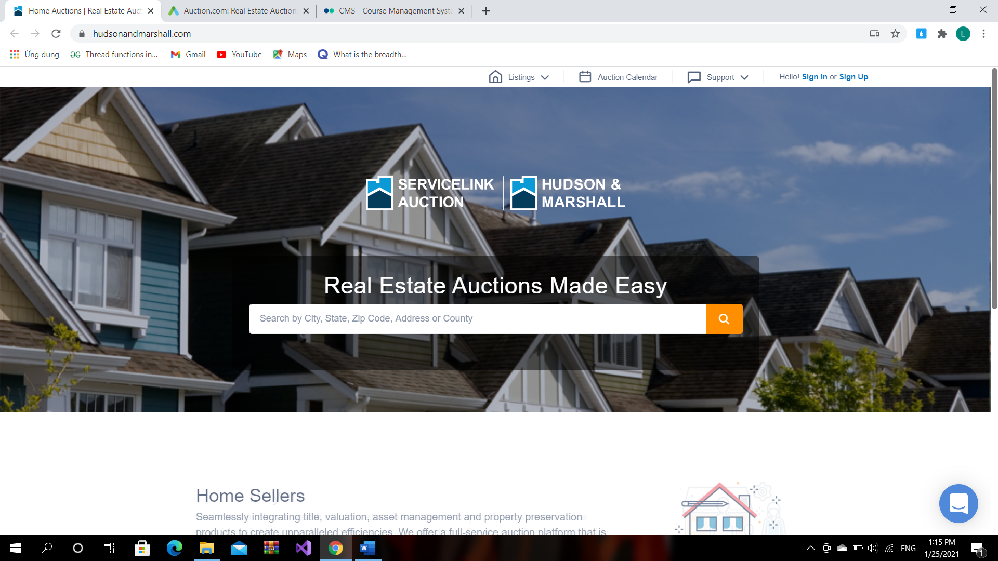

.

*Figure 5.1-1: Trippy home page*

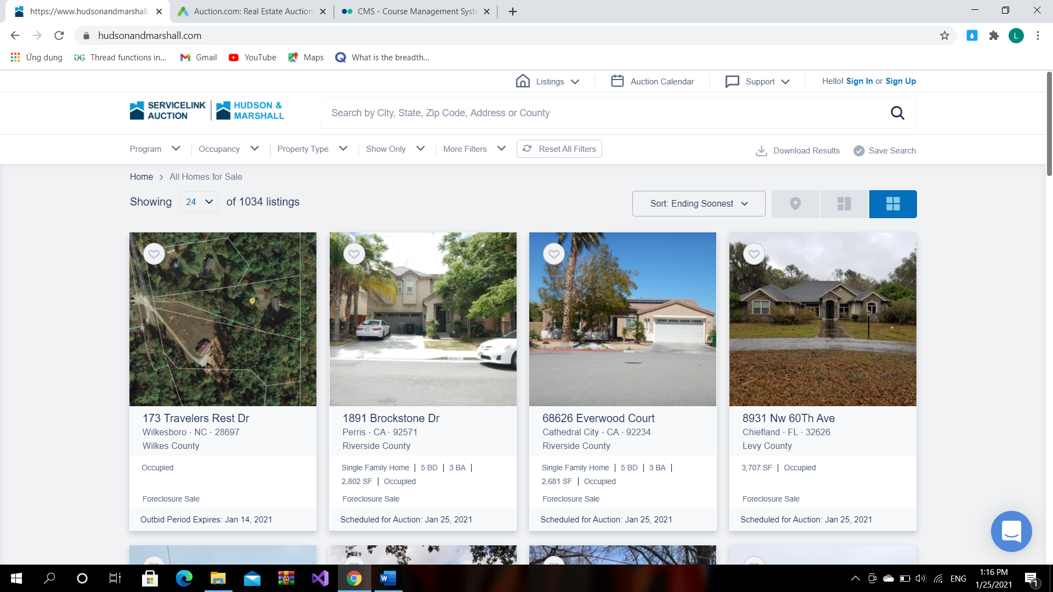

*Figure 5.1-2: All list amusement park page*

Secondly, we don't need to verify an account but still can book ticket with fake information.

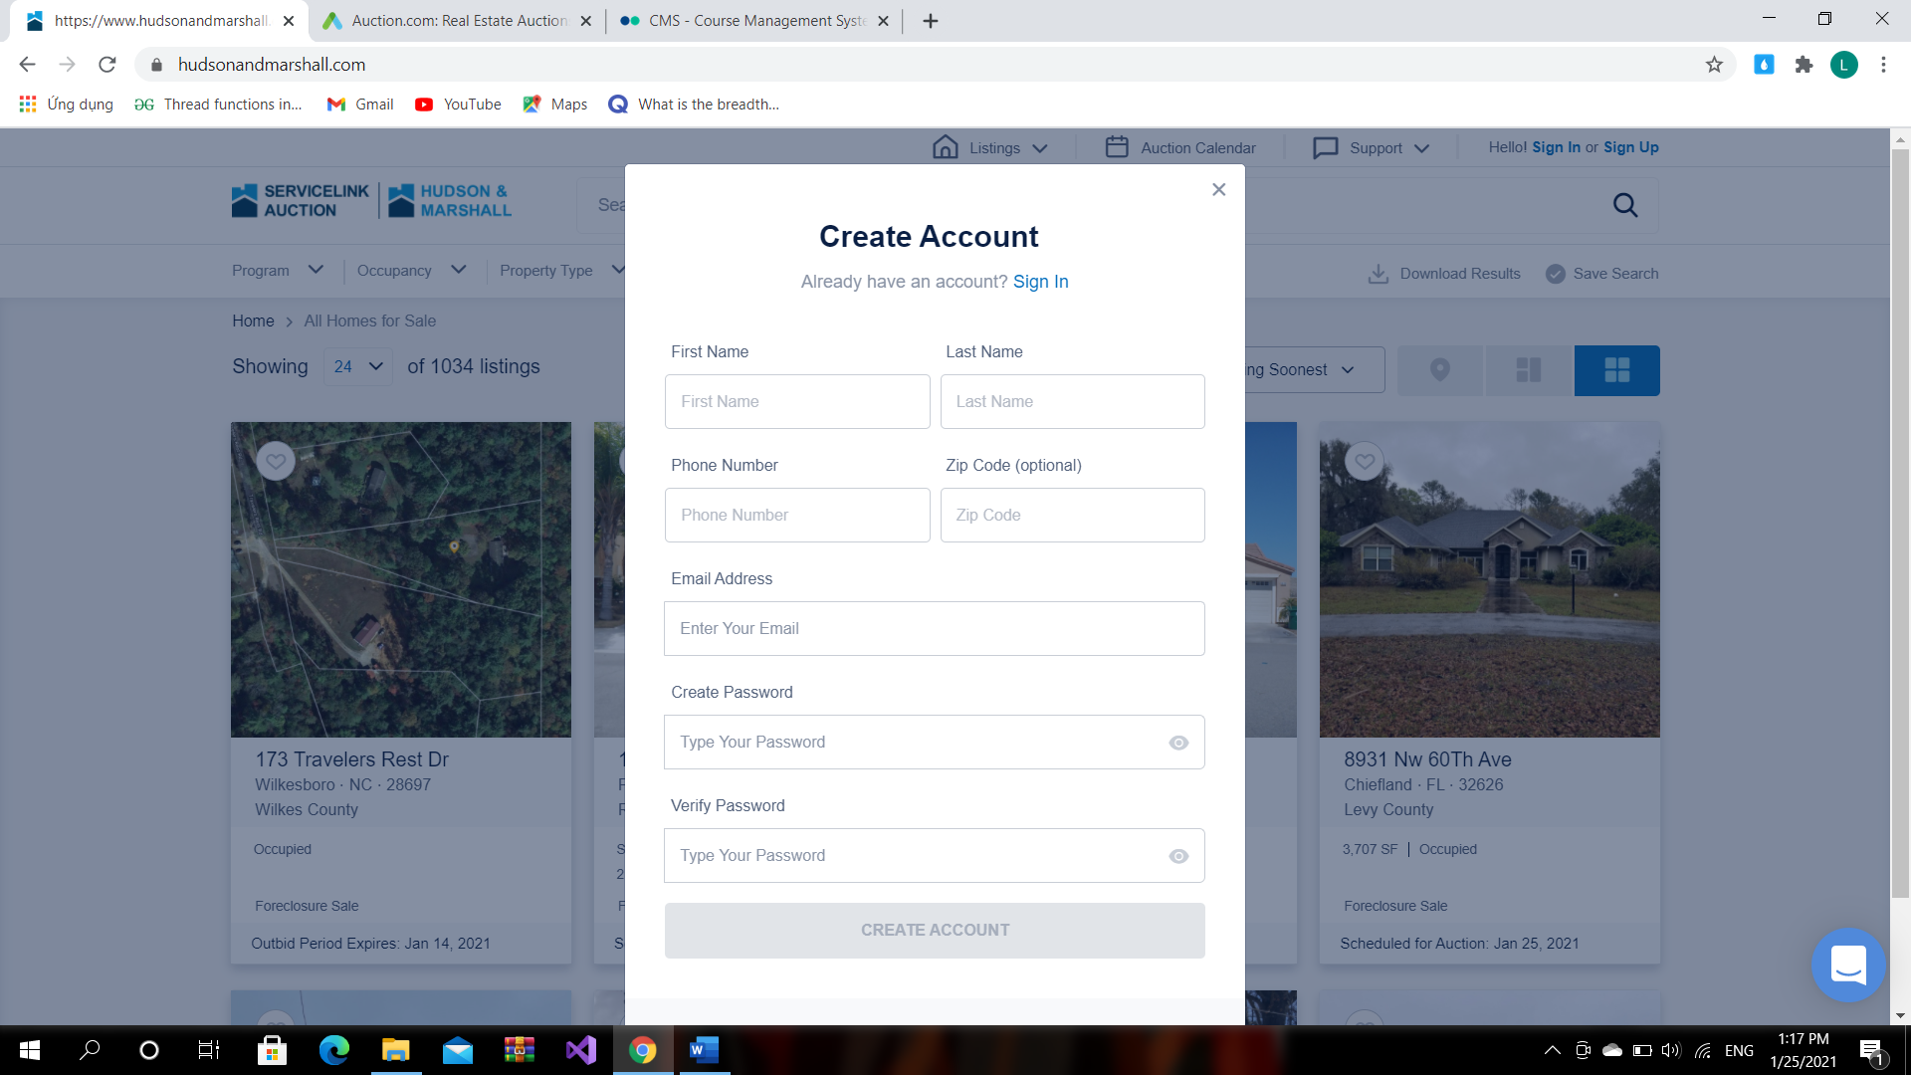

*Figure 5.1-3: View user information*

### 5.2. auction



*Figure 5.2-1: Auction home page*

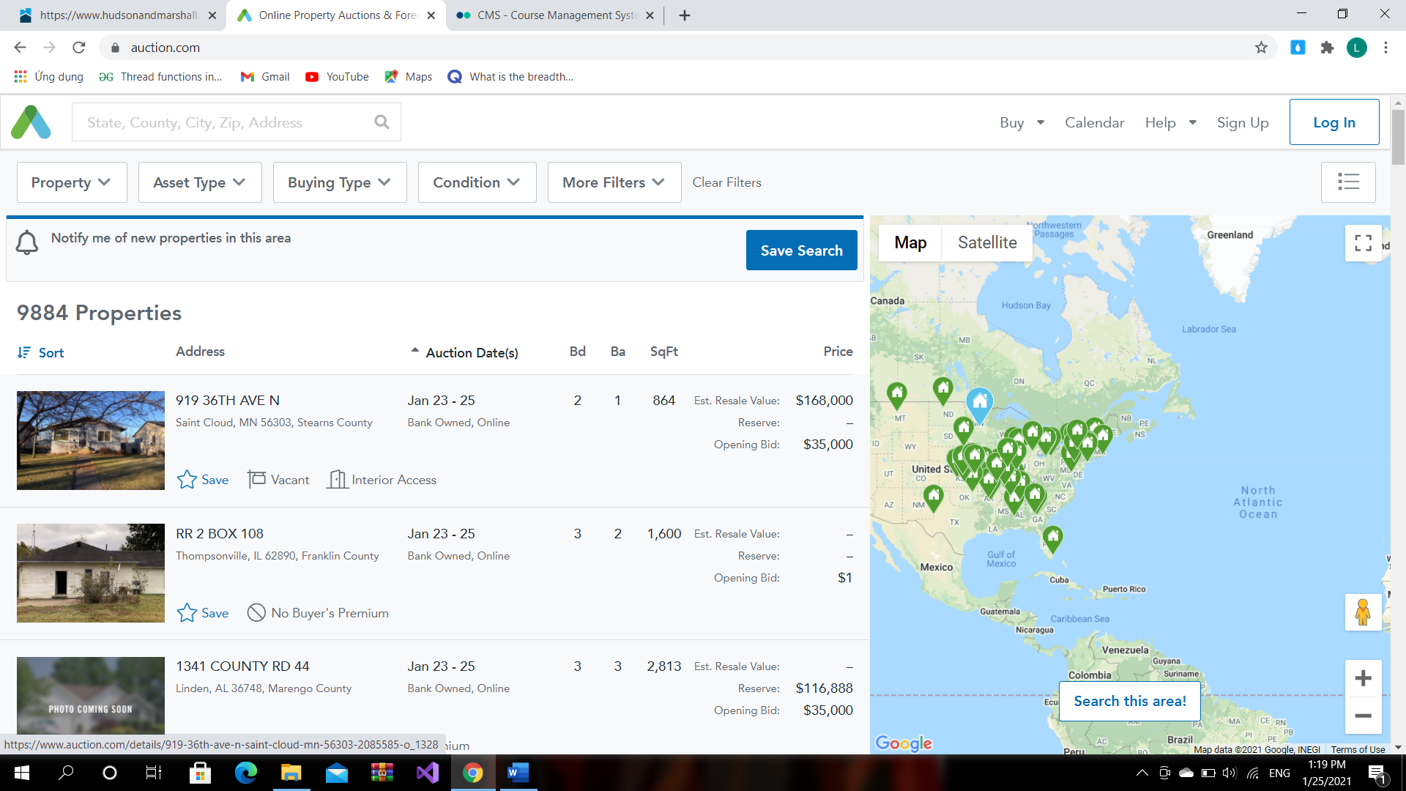

*Figure 5.2-2: Auction home page*

## 6. Proposed Solution

### 6.1. Solution Description

Our product is an entertainment service that focuses on amusement park, so our system will have the following characteristics:

x Intuitive interactions:

Basic functionality will be easy to recognize and use, the UI will provide an elegant look that makes the user feel more comfortable when interacts. x Availability:

Our service will be available on the web platform which will help users get to access more easily. x Personalized experience:

Each user can search and book amusement parks based on their interests and accommodation. x Open and Convenient:

Login and payment method are abundant

### 6.2. System Actors

#### 6.2.1. Web/Front-End

|  |  |  |
| --- | --- | --- |
| **#** | **Actor** | **Actor Description** |
| 1 | Guest | People who don’t have an account on the service yet. They are just able to view and search for amusement parks only. They will have to register a new account to be able to use the features which the service provides. |
| 2 | User | People who possess an account on the website. They will  be able to sign-in and use all of the features available. |

*Table 6.2.1-1: Web/Front-End’s actors*

#### 6.2.2. Admin Board

|  |  |  |
| --- | --- | --- |
| **#** | **Actor** | **Actor Description** |
| 1 | Admin | People who are assigned with a system-generated account. Their jobs are to manage service account systems. |
| 2 | Staff | People who are assigned with a system-generated account. Their jobs are to manage user accounts and order ticket in the system. |

*Table 6.2.2-1: Admin board’s actors*

### 6.3. System Features

|  |  |  |  |
| --- | --- | --- | --- |
| **#** | **Roles** | **Features** | **Feature Description** |
| 1 | Admin | Admin web login | Sign-in and Log-out from Admin web |
| 2 | Admin | Information of amusement parks management | Add, delete and edit information of amusement parks |
| 3 | Admin | Customer Information  Management | Add, change status and edit information of customer |
| 4 | Admin | Transaction information management | Explore transaction information |
| 5 | Admin | Ticket types management | Add, delete and edit tickets |
| 6 | Admin | Revenue statistics | Explore revenue statistics of amusement parks |
| 7 | Guest | Sign-up a new account |  |
| 8 | User | Sign-in/Log-out |  |
| 9 | User, Guest | Explore amusement parks | Search amusement parks by name |
| 10 | User | Tickets Booking | Order ticket |
| 11 | User | Payment |  |

*Table 6.3-1: System features*

### 6.4. Intended Screen Flow

#### 6.4.1. Online Real Estate screen flow

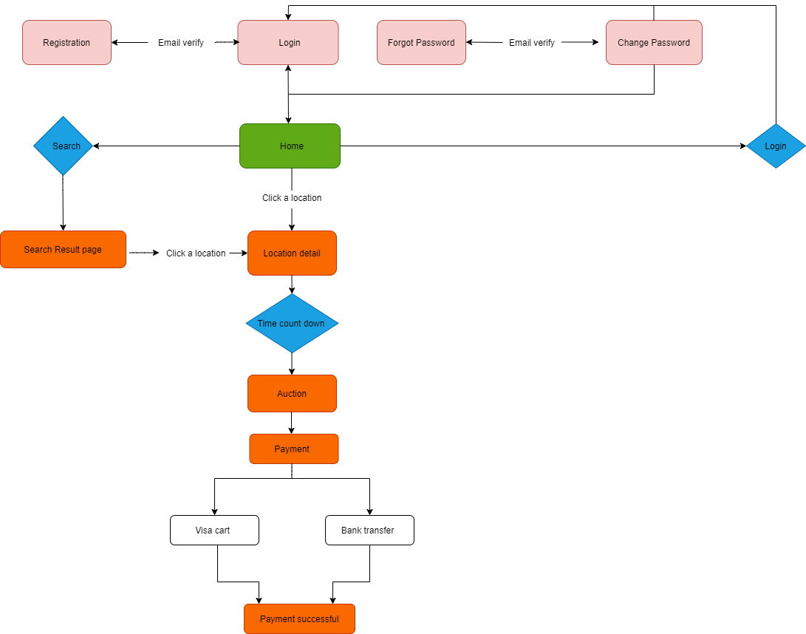

*Figure 6.4.1-1: Online Real Estate screen flow*

#### 6.4.2. CMS screen flow

#### 

*Figure 6.4.2-1: CMS screen flow*

### 6.5. Technologies

Programming Languages: x Java 8 x JavaScript ES6 x JSX (JavaScript XML)

Frameworks and Libraries: x Spring Boot v2 x React JS v16 x Redux v4

Database: x MySQL Database

Platforms:

x Web Browser

Technologies: x Amazon Elastic Beanstalk. x Amazon RDS. x Amazon EFS or S3.

## 7. Constraints & Assumptions

### 7.1. Project Constraints

x Deadline will be fulfilled on time. x Team members are capable of doing their work and report accordingly. x There are no changes in HR during the course of the project.

### 7.2. Project Assumptions

x Time: 15 weeks until final product and documents. x HR: 5 members of the project team. x Deadline for each phase is specified.

## 8. Out of scope functions (範囲外)

x Currently, our website version works only on PC browsers. Not supported on devices such as phones, tablets ...

x No support registration, login with social network accounts. x The system does not automatically send tickets to users, requiring staff support. x The system has not processed the situation if the user spam orders.

x Currently, the system only has a visa method to be verified. Also, the bank transfer method needs to be re-verified.

# CHAPTER 2

**PROJECT PLAN -** プロジェクト計画

## 1. Overview （概要）

### 1.1. Scope （範囲）

x This project will produce a website booking amusement ticket in VietNam. The amusement parks in the system are 100% in the territory of Vietnam, current target that users all of Vietnamese.

x With digital and information technology platforms developed, tourists can learn, book amusements ticket, make reservations and actively buy tickets, pay easily visa card or bank accounts line.

x Due to the time and the capability of our team, the app version will not be provided during this time.

x The stages associated with the ticket provider, commercial connection with amusement parks will not be conducted, all of which will be done in the form of resimulation according to the actual process.

x The management of this project will include analysis, design, implementation and testing. This project will be carried out for a fixed duration, maintenance and further features enhancement will not be included in the working flow.

### 1.2. Objectives （目的）

x This project will be carried out in 15 weeks starting from 18/05/2020, working days will have at least 8 hours attempt and also include the weekend

x Each milestone will produce a deliverable with review and details update for the previous deliverable.

x Documents will follow the standard template and easy to interpret.

x The final product will be deployable to Amazon Web Service(AWS) before the end of week 12 with all specified functionality.

### 1.3. Project Risks （プロジェクトリスク）

|  |  |  |  |  |
| --- | --- | --- | --- | --- |
|  | Risk Description | Impact | Possibility | Response Plans |
| 1 | Some team members lack experience in technology used in the project | High | High | Establish 4 week training before the design phase |
| 2 | School schedule conflicts with project schedule | Low | Low | Meeting result will be informed to that member in person by team lead |
| 3 | Technical difficulty | Medium | Medium | Provide extra time for research and  implementation |
| 4 | Some requirements may not have been analyzed carefully | High | High | Apply incremental update to SRS |
| 5 | Estimation for task required effort may be incorrect | Medium | High | Require extra time and resource |
| 6 | Project team Member  misunderstands requirement | High | Low | Members need to redefine their mission before each stage. |

*Table 1.3-1: Project risks*

## 2. Management Approach （プロジェクト管理アプローチ）

### 2.1. Project Process （プロジェクトプロセス）

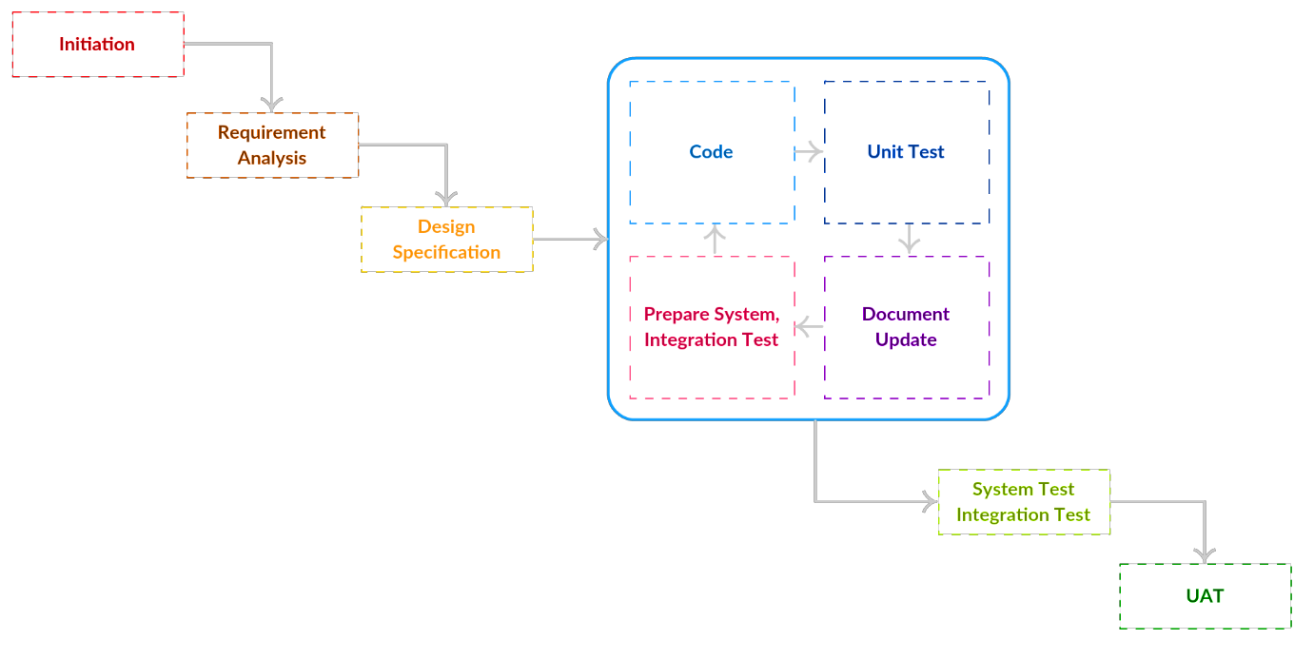

*Figure 2.1-1: Project process*

### 2.2. Change Management （変更管理）

|  |  |
| --- | --- |
| Where is the change request logged? | RequirementChangeManagement.xls |
| Who logs the change requests? | PM |
| Who reviews the change requests? | PM, BA |
| Who approves the change requests? | PM |

*Table 2.2-1: Change Management*

### 2.3. Quality Management （品質管理）

#### 2.3.1. Defect Prevention Strategy （欠陥防止戦略）

|  |  |  |
| --- | --- | --- |
| Item  (Process/Product) | Strategy | Expected Benefits |
| Requirement Ambiguity | A quick review and analyze to agree on the flow of use-case | Clear use-case and reduce code implementation |
| Wrong Design | Ask instructor clearly before design | Save time |
| Weak coding skill | Training from week 2 | Reduce bug and time to fix |

*Table 2.3.1-1: Defect prevention strategy*

#### 2.3.2. Review Strategy （レビュー戦略）

|  |  |  |
| --- | --- | --- |
| Review Item | Reviewer | Review Type |
| Project Introduction | Instructor | One-side review |
| Project Management Plan | Instructor | One-side review |
| Software Requirements  Specification | BA, Instructor | One-side review Group review |
| Software Design Document | BA, Instructor | One-side review Group review |
| Code Package | Tech Lead | Group review |
| Test Case | BA, Instructor | Group review |

*Table 2.3.2-1: Review strategy*

### 2.4. Project Training Plan （プロジェクト研修計画）

|  |  |  |  |
| --- | --- | --- | --- |
| Training Area | Participants | When, Duration | Waiver Criteria |
| Java Spring Boot | Nguyễn Vũ Hiếu | Start of week 1 : 3 weeks duration | Mandatory |
| ReactJS | Vương Minh Hiếu | Start of week 1: 3 weeks | Mandatory |
| Git, Github | Đào Quang Toàn  Vương Minh Hiếu Nguyễn Vũ Hiếu | Start of week 1: 2 weeks | Mandatory |
| Document | Vũ Thị Phương Thảo | Start of week 1: 2 weeks | Mandatory |
| Selenium Test | Phùng Trí Đức | Start of week 1: 3 weeks | Mandatory |

*Table 2.4-1: Project training plan*

## 3. Estimation & Master Schedule （見積もりとマスタースケジュール）

### 3.1. Project Size （プロジェクトサイズ）

#### 3.1.1. Web

|  |  |  |  |
| --- | --- | --- | --- |
|  | Feature | Screen/Service | Size |
| 1 | Authentication | Sign in with Email | Medium |
| 2 | Authentication | Logout | Medium |
| 3 | Account Management | Edit account details | Medium |
| 4 | Account Management | Change password | Simple |
| 5 | Account Management | Edit settings | Simple |
| 6 | Browse | Search amusement parks | Medium |
| 7 | Browse | Search location | Medium |
| 8 | Browse | Home | Medium |
| 9 | Browse | Order ticket | Medium |
| 10 | User Management | My order | Hard |
| 11 | User Management | Profile | Simple |
| 12 | User Management | Edit profile | Simple |
| 13 | User Management | Payment | Simple |
| 14 | User Management | Transaction statistics | Medium |
| 15 | Parks Management | Amusement park’s page | Simple |

*Table 3.1.1-1: Project size - web*

#### 3.1.2. CMS

|  |  |  |  |
| --- | --- | --- | --- |
|  | Feature | Screen/Service | Size |
| 1 | CMS | CMS Login | Simple |
| 2 | CMS | CMS Logout | Simple |
| 3 | CMS | Add/Remove User | Medium |
| 4 | CMS | Add/Remove/Deactivate Place | Medium |
| 5 | CMS | Add/Remove Category | Medium |
| 6 | CMS | Add/Remove/Deactivate Game | Medium |
| 7 | CMS | Add/Remove City | Medium |
| 8 | CMS | Add/Remove/Deactivate Ticket type | Medium |
| 9 | CMS | Add/Remove/Deactivate Visitor type | Medium |
| 10 | CMS | Order | Medium |
| 11 | CMS | Sale report | Medium |

*Table 3.1.2-1: Project size - cms*

### 3.2. Deliverables （成果物）

|  |  |  |  |  |
| --- | --- | --- | --- | --- |
|  | Deliverable | Effort | Due Date | Notes |
| 1 | Project Plan | 28 | 18/05 | Project Management Plan |
| 2 | SRS | 28 |  | Software Requirement Specification |
| 3 | Design | 56 | 23-30/05 | Architecture Design, Detailed Design, Database |
| 4 | Code Package1 | 56 |  | Code & Unit test, System test cases |
| 5 | Code Package2 | 56 |  | Code & Unit test, System test cases |
| 6 | Code Package3 | 56 |  | Code & Unit test, System test cases |
| 7 | UAT Package | 28 |  | Codes, System test reports |
| 8 | Final Package | 56 | 10/08/2020 | Final Codes & documents, User manual |

*Table 3.2-1: Deliverables*

### 3.3. Detail Schedule （詳細なスケジュール）

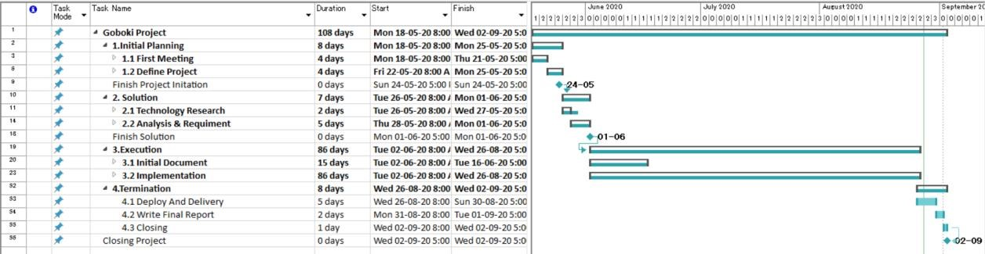

*Figure 3.3-1: Detail schedule*

### 3.4. Project Organization （プロジェクト組織）

#### 3.4.1. Team & Structures （チームと構造）

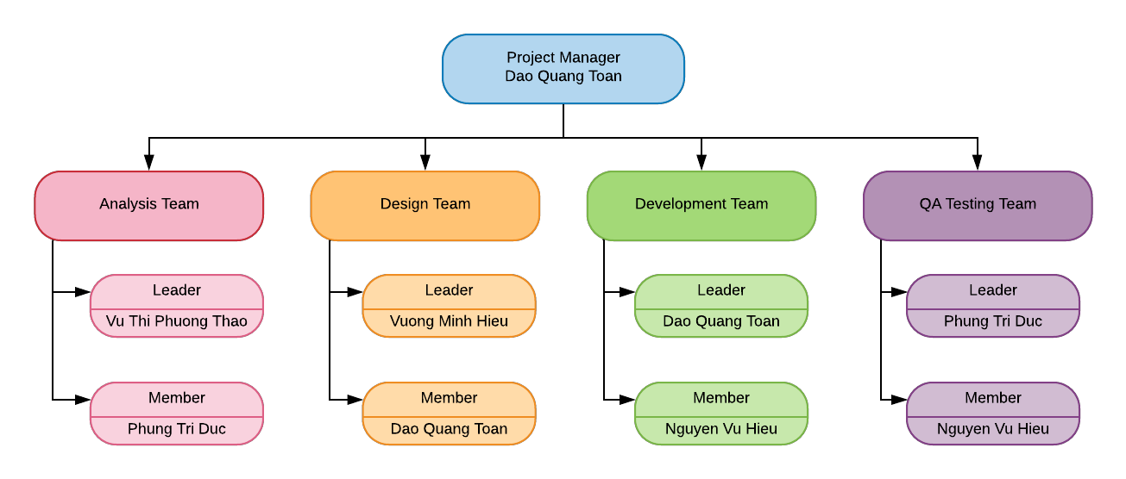

*Figure 3.4.1-1: Team & Structures*

#### 3.4.2. Roles & Responsibilities （役割と責任）

|  |  |
| --- | --- |
| Role | Responsibility |
| Project Manager | Dao Quang Toan |
| Analysis Leader | Vu Thi Phuong Thao |
| Analysis Member | Phung Tri Duc |
| Design Leader | Vuong Minh Hieu |
| Design Member | Dao Quang Toan |
| Technical Leader | Dao Quang Toan |
| Technical member | Nguyen Vu Hieu |
| Test Leader | Phung Tri Duc |
| Test Member | Nguyen Vu Hieu |
| Test Member | Vu Thi Phuong Thao |
| Test Member | Dao Quang Toan |

*Table 3.4.2-1: Roles & Responsibilities*

### 3.5. Communication （プロジェクトコミュニケーション）

#### 3.5.1. Communication Plan （コミュニケーションプラン）

|  |  |  |  |  |
| --- | --- | --- | --- | --- |
| Communication Item | Who/ Target | Purpose | When,  Frequency | Type,  Method(s) |
| Daily meeting | Project team | Update on progress and assign tasks to members | Daily | Google meet,  Offline,  Messenger |
| Weekly meeting | Project team and Supervisor | Update for project progress and Supervisor  review | Weekly | Offline, Skype |

*Table 3.5.1-1: Communication Plan*

#### 3.5.2. External Interface （外部インタフェース）

##### 3.5.2.1. FU Contacts

|  |  |  |  |
| --- | --- | --- | --- |
| Function | Contact Person (name, position) | Contact address (email, telephone) | Responsibility |
| Supervisor | Pham Ngoc Ha | HaPN10@fe.edu.vn 0988623000 | * Provide document template - Give instructions to project team * Review deliverables * Supervise project status |
| Supporter | Nguyen Thi Mai Phuong | Phuongntm5@fe.ed  u.vn | * Provide document template * Receive report project * Answer questions about the project |

*Table 3.5.2.1-1: Fu contarts*

##### 3.5.2.2. Customer Contracts

|  |  |  |  |
| --- | --- | --- | --- |
| Function | Contact Person (name, position) | Contact address (email, telephone) | Responsibility |
| Supervisor | Pham Ngoc Ha | HaPN10@fe.edu.vn 0988623000 | * Provide document template - Give instructions to project team * Review deliverables * Supervise project status |
| Supporter | Nguyen Thi Mai Phuong | Phuongntm5@fe.ed  u.vn | * Provide document template * Receive report project * Answer questions about the project |

*Table 3.5.2.2-1: Customer contracts*

### 3.6. Configuration Management （構成管理）

#### 3.6.1. Tools & Infrastructures （道具とインフラ）

|  |  |
| --- | --- |
| Programming languages | Java, ReactJS |
| Framework | Java Spring Boot |
| API | API |
| DBMS | My SQL |
| IDEs/Editors | Visual Studio Code, IntelliJ |
| UML tools | Visual Paradigm, Astah, Lucidchart |
| Version Control | GitHub |
| Deployment server | Amazon Web Service |
| Project management tool | Trello |

*Table 3.6.1-1: Tools & Infrastructures*

#### 3.6.2. Document Management （資料管理）

* All documents will be managed in a Google Drive with the following structure

○ “content” folder: Contain project content

■ “document”: project reports, required and additional documents.

* Each document report will be named in the format:

Report#_”Report Name”_SWP493_G2

■ “resource”: image, video, resources for the project.

○ “reference” folder: Contain reference resources ● Updates, changes will be recorded each week.

#### 3.6.3. Source Code Management （ソースコード管理）

x Team members use GitHub for source code and version control. x Team members are only allowed to commit code to the local repository.

x Code must be fully tested and run well on the local side before sending pull request to master repository for finished implementations.

x Main branch will be hosted on GitHub and can only be changed by pulling from pull request by local dev branch.

x Pull request will be peer reviewed to determine whether it will be accepted or block.

# CHAPTER 3

**SOFTWARE REQUIREMENT SPECIFICATION -**

## 1. Product Scope

GoBoKi 1.0 is a web-based ticket booking online application that allows users to book, explore the amusement parks in VietNam through a simple and intuitive interface. This service will provide most functions without charge. At this time, the system is supporting the customer's payment with visa cards. However, the system does not support customers to refund, so there is a need to cancel tickets.

This project will also deliver a CMS system to manage some important entities.

## 2. Functional Requirements

### 2.1. Use case diagram

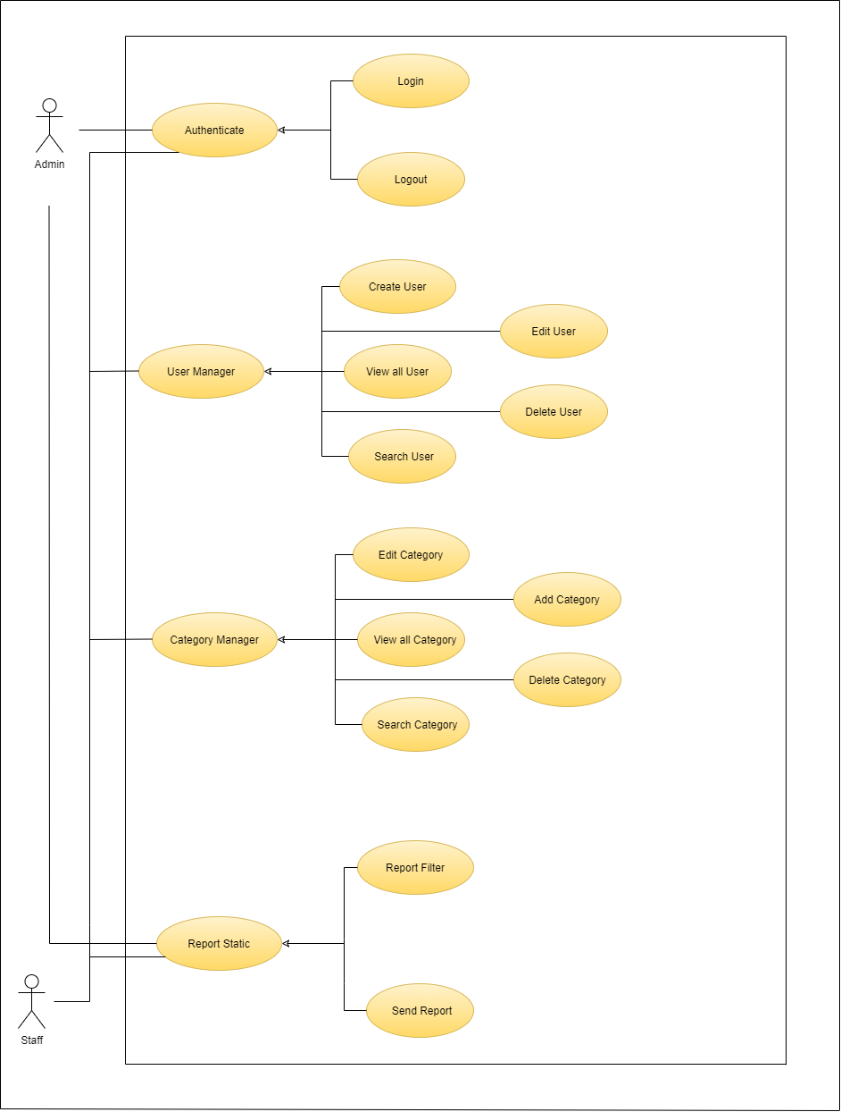

*Figure 2.1-1: CMS use case diagram*

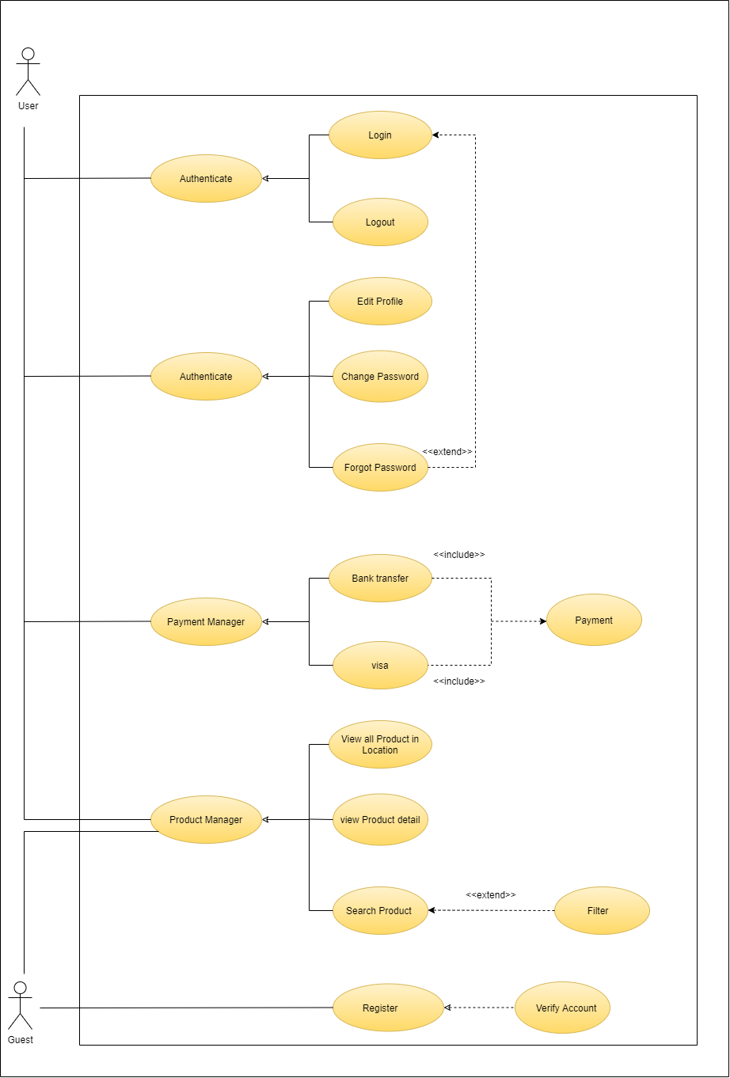

*Figure 2.1-2: User’s use case diagram*

### 2.2. Business Rules

|  |  |
| --- | --- |
| ID | Description |
| B01 | Account's email address must be valid. |
| B02 | Account's password must be from 8-20 characters in length and must contain at least 1 uppercase letter, lower case letter and digit. |
| B03 | When registering, or changing password, user must enter the new password twice. |
| B04 | A guest must provide their email address and password when registering an account. |
| B05 | A guest cannot register with an email that has already been registered. |
| B06 | After registering, guest must activate their account with the activation link sent to the account's email address. |
| B07 | User must provide their account's email address and password when logging into the website. |
| B08 | User cannot login to their account unless the account is activated. |
| B09 | User must provide their account's email address when resetting the account's password. |
| B10 | When changing password, new password must not be the same as the current |
|  | password. |
| B11 | An account must belong to one of the three roles: User, Admin, Staff. |
| B12 | Only Admin or Staff accounts can login to the CMS system. |
| B13 | Only Administrator accounts can manage User, Place, Game, Ticket in the system. |
| B14 | There cannot have two places with the same name. |
| B15 | User has to login before booking a tour. |
| B16 | Park, game and ticket information of update or add mode must be different from details of data in the database. |
| B17 | Ticket type must be chosen. |
| B18 | Redemption date must be chosen. |
| B19 | Amount of ticket must be chosen. |
| B20 | All information about the park must be entered. |
| B21 | Price must be a positive number. |
| B22 | User must be received confirmation mail to go to the payment page. |
| B23 | A Place must have at least one game. |
| B24 | A game must belong to at least one Place. |
| B25 | User only can be received ticket when completed payment. |
| B26 | The search section will be on top of the screen as part of the one-page layout of the web version. |
| B27 | Each Facebook account can only be used to register to the service once. |
| B28 | Purchased money cannot be refunded. |
| B29 | The searching process will only happen after the user hits Enter. |
| B30 | There cannot have two games with the same name. |
| B31 | All information of game must be entered. |
| B32 | A Place must have at least one ticket type. |
| B33 | A ticket type must belong to one Place. |
| B34 | All information of ticket must be entered. |
| B35 | When login with Facebook, this account is auto set in User role. |
| B36 | Each email address can be used for only one account |
| B37 | There cannot have two ticket types with the same name. |
| B38 | There cannot have two visitor types with the same name. |
| B39 | A ticket type must belong to one visitor type. |
| B40 | There cannot have two cities with the same name. |
| B41 | All information of city must be entered. |
| B42 | Must have at least one city in the system. |
| B43 | No need to fill in all the information fields when searching |
| B44 | There cannot have two categories with the same name. |
| B45 | All information of category must be entered. |
| B46 | Uploaded files must be in ".XLSX" format |

*Table 2.2-1: Business Rules*

### 2.3. Use Cases

The system consists of 31 use cases for four types of actors. Below are the lists of actors and use cases:

|  |  |
| --- | --- |
| **Actor** | **Description** |
| User | Customers who have an account and can use all functions of this website |
| Guest | Everyone who does not have an account on the Online Real Estate Auction system |
| Admin | A group of people who has the authority to manager the issuers and system’s status |
| Staff | A staff that can view transaction information and send ticket to user’s email |

*Table 2.3 – 1: User’s role*

|  |  |  |
| --- | --- | --- |
| ID | Actor | Name |
| UC-1 | Amin, Staff, User | Login |
| UC-2 | Amin, Staff, User | Logout |
| UC-3 | Admin | Create User |
| UC-4 | Admin | Edit User |
| UC-5 | Admin | View all Users |
| UC-6 | Admin | Remove User |
| UC-7 | Admin | User Search |
| UC-8 | Admin | Add Product |
| UC-9 | Admin | Edit Product Information |
| UC-10 | Admin | Remove Product |
| UC-11 | Admin | View all Product |
| UC-12 | Admin | Product Search |
| UC-13 | Admin | Change Status Product |
| UC-14 | Admin | View all Category |
| UC-15 | Admin | Add Category |
| UC-16 | Admin | Edit Category |
| UC-17 | Admin | Remove Category |
| UC-18 | Admin | Search Category |
| UC-19 | Admin, Staff | Report Filter |
| UC-20 | Admin, Staff | Send Report |
| UC-21 | User | Edit Profile |
| UC-22 | User | Change Password |
| UC-23 | User | Forgot Password |
| UC-24 | User | Visa Card |
| UC-25 | User | Bank Transfer |
| UC-26 | User, Guest | View all Product in a Location |
| UC-27 | User, Guest | View Product Detail |
| UC-28 | User, Guest | Search |
| UC-29 | User, Guest | Filter |
| UC-30 | Guest | Register |
| UC-31 | Guest | Verify account |

*Table 2.3 – 2: Use case*